**Q-Project**

The SRS Produces Cumulative Analysis of the task and also produces technical specifications requirements of our Q-Project.

**Purpose:**

The main purpose of our system is to make our Q-Project task easy and is to developed login page, Client details Form and Client Campaign Report. This document serves as the unambiguous guide for the developers to run their source code, if any difficulties faced during the usage of the test code.It manages multiple projects for a given client, focusing on the long-term consequences of the portfolio of projects it manages for the customer's business

**Scope:**

The document only covers the requirement specifications for the Q-Project .This document does not provides any references to the other component of the Q-Project. All the external interfaces and the dependencies are also identified in this document.

**Specific Requirements:**

It describes all the details that the software developer need to know for designing and developing the system. This is typically the largest and most important part of the document.

Software’s Required: Versions

* HTML(Hypertext Mark-up Language) HTML 5
* CSS (Cascading Style Sheet) CSS 3
* Bootstrap Bootstrap 5
* JavaScript ES 6
* MySQL 8.0.32
* Python Pyhton 3.11
* D-Jango 4.1.6
* Operating System Windows 11

**Abstract:**

The Q-Project is a document that is used to gather information about login user and SuperAdmin,in login page if login with SuperAdmin a new client details, including their company information,as well as their advertisement history, and ad revenue like CPM, CPC, Planned Cost. The purpose of the form is to create an annual report of their company income through the calculations of the revenue which are mentioned as like above.

The form is typically includes fields for Client Name, Client Company Name, Start Date, End Date, Company logo. This form is important for the company revenue when the advertisement posted by the publisher and user views and clicks and the revenue is usually filled out during the calculation process.

**TEAM MEMBERS:**

* Chandra
* Yogee
* Harish
* Sneha
* Shivani
* Nikhil
* Vignan
* RohitSai
* Naveen
* RaviTeja
* Anitha
* Harsha
* Srikar
* Lakshmi

**Tasks:**

* We have to create the login page in HTML and we have to give the login details (user and superadmin).
* We have to create the project in D-Jango.
* We have to create the database in MySQL.
* We have to link the HTML page and D-Jango application.
* We have to give login access to the user and superadmin
* Superadmin having all access to edit the data.
* User and superadmin details present in the database we have to do.

**HTML & CSS:**

* HTML5 is the fifth revision of the HTML standard and brings a range of new features and capabilities to web development.
* Some of the most notable features include improved support for multimedia content, such as video and audio, new semantic elements to describe different parts of a web page, and improved support for offline web applications.
* CSS3, on the other hand, is the latest version of the style sheet language used to describe the look and formatting of a web page. It provides a range of new selectors, properties, and techniques for creating modern, dynamic, and responsive web pages. Some of the most notable features in CSS3 include support for responsive design, new layout an positioning techniques, and advanced effects and animations.
* Together, HTML5 and CSS3 provide a powerful platform for creating modern, dynamic, and engaging websites and web applications.
* By using Html5& Css3 we have developed following web pages:
* Login.html (User, Super Admin)
* Client details.html
* User Details.html(Task Creation and Report)
* Client Report

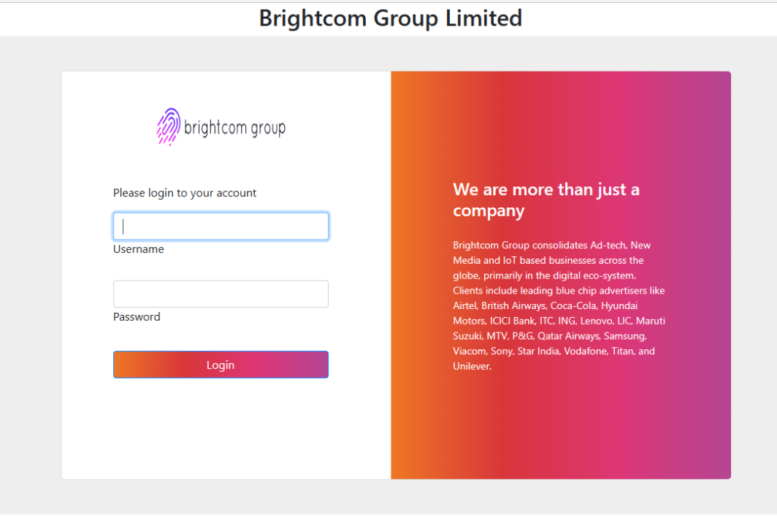

Login Page(Super Admin, User)

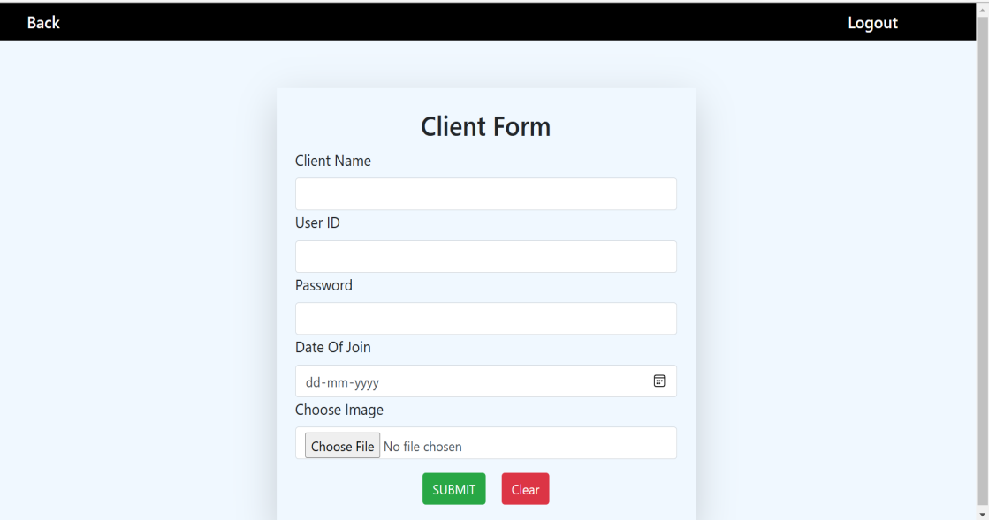

Client Details Form

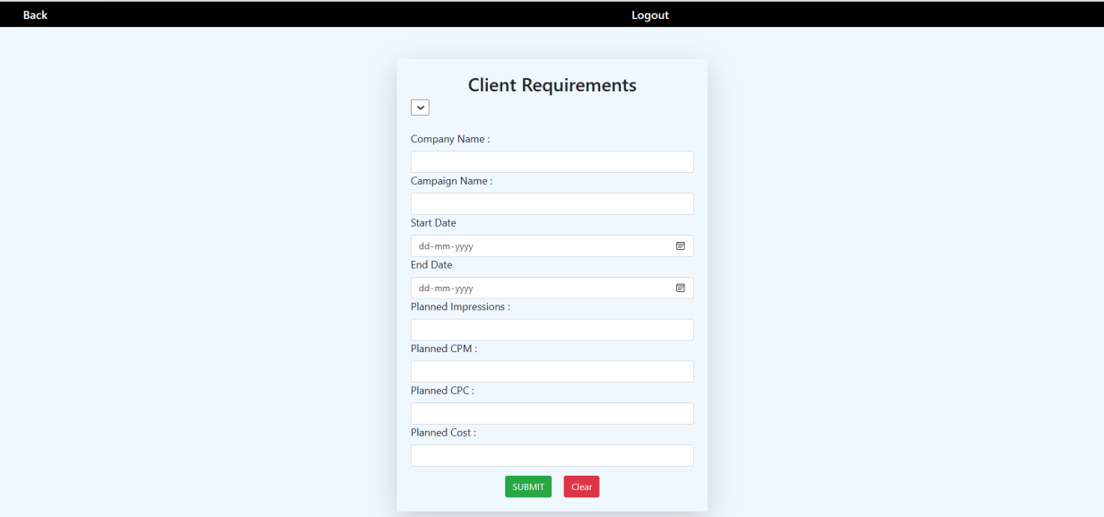

User Details(Task Creation)

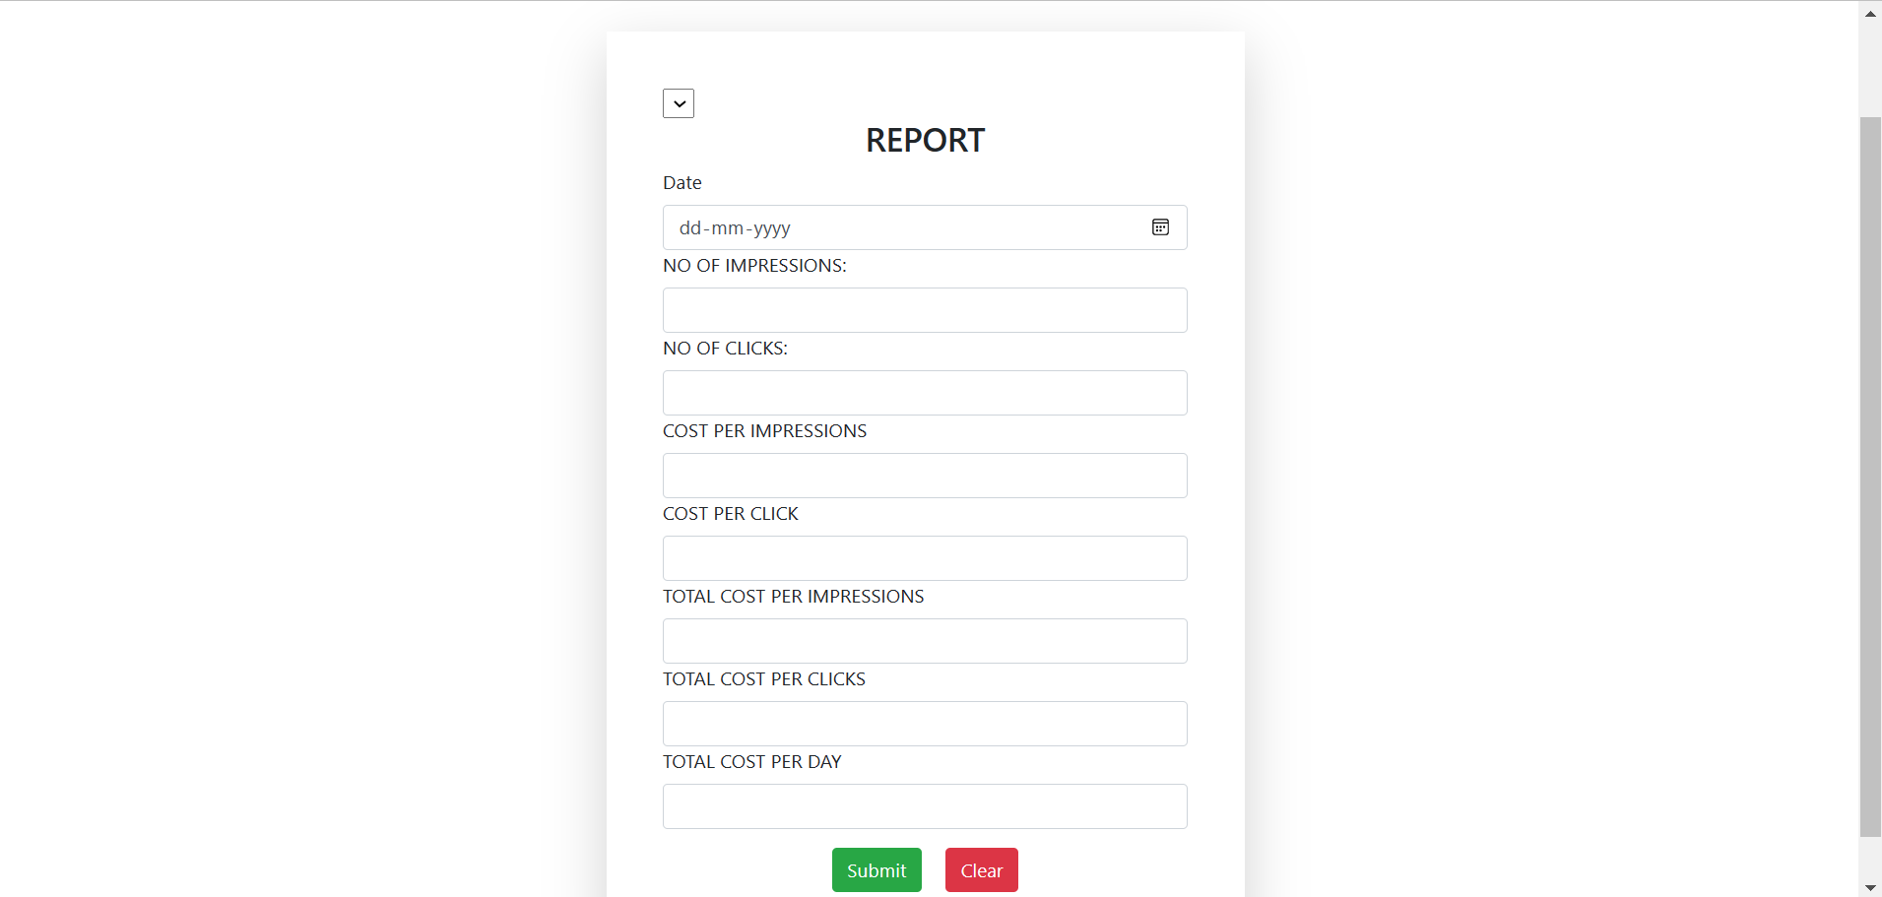

User(Report)

**BootStrap:**

Bootstrap is a popular open-source front-end framework used for developing responsive and mobile-first websites and web applications. It was developed by Twitter and was originally released in 2011.

Bootstrap is based on HTML, CSS, and JavaScript and provides a set of pre-designed components, such as navigation bars, buttons, forms, and modals, that can be easily added to a project to create a user-friendly interface. It also provides a grid-based layout system that makes it easy to create responsive, multi-column designs.

Bootstrap also includes a number of CSS classes that can be used to style elements on a page and to implement various design elements, such as typography, colours, and spacing.

The framework also supports JavaScript plugins for adding interactivity to a page, such as dropdown menus and carousels.

Bootstrap is widely used by developers and designers for its simplicity and versatility. It allows for quick and easy prototyping, and can be customized to fit the specific needs of a project.

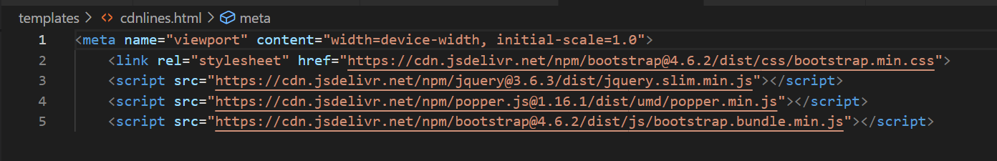

Bootstrap

**Python & D-Jango:**

**D-Jango:**

Django is a framework which is used to create/design web-application.django is 3rd party module.

**D-Jango Feautres:**

* We can create any application with in less time.
* Django is versatile framework because we can create any kind of domine (sales,health........) websites.
* Django is more securable because lot of pre-define code with more security.
* Django supports all databases like mysql,sql,.........
* Django is portable framework.

**D-Jango Application:**

* Django project is a collection of applications along with their configurations.
* A project must required atleast one aplication and almost n number of application.
* Django-admin.py file will be installed automatically where we install django.
* We use django-admin.py file to create django project.

**Syntax:**

* django-admin start project <project name>
* An application is a specific task of the project.

**Manage.py:**

* Manage.py file will be create automatically whenever we create project.
* We use manage.py file to create django application.
* Also use startapp command along with manage.py file to create django application.

**Syntax:**

* python manage.py startapp <appname>

**General Points:**

* Django follows MVT model

M----->model-------------->to write databases related code.

V------->views------------> to write business related code.

T------>templates-------->to write presentation related code .

**Mysql:**

* MySQL is a widely-used open-source relational database management system (RDBMS).
* It is used for storing, organizing, and retrieving data in a structured way. MySQL is a popular choice for web-based applications, as it is fast,  reliable, and easy to use.
* MySQL is based on the Structured Query Language (SQL), which is used to create, manipulate, and query the data stored in a database.
* In MySQL, data is stored in tables, which consist of rows and columns. Each row represents a single record, and each column represents a specific field of data.
* MySQL provides a number of features that make it a powerful tool for managing data, including:
* Data security: MySQL provides a number of security features to ensure the protection of data stored in a  database, including user authentication and access  control.
* Scalability: MySQL can handle large amounts of data  and can easily be scaled up to support growing  amounts of data.
* High performance: MySQL is optimized for fast  performance and can handle large amounts of data  and concurrent users.
* Cross-platform support: MySQL runs on a variety of  platforms, including Windows, macOS, and Linux,  and can be used with a wide range of programming  languages, including PHP, Java, and Python.

Overall, MySQL is a widely-used and reliable database  management system that is well suited for web-based  applications and other data-intensive projects.

Note: we have to create Database by following Quary

To connect database remotely we have to run following  commands in our mysql database:

* create user 'root'@'%' identified by 'admin';
* grant all privileges on *.* to 'root'@'%' with grant  option
* flush privileges;

we have to configure database in settings.py

We have to create table in modules.py by using following  quary in mysql: create database formdb;

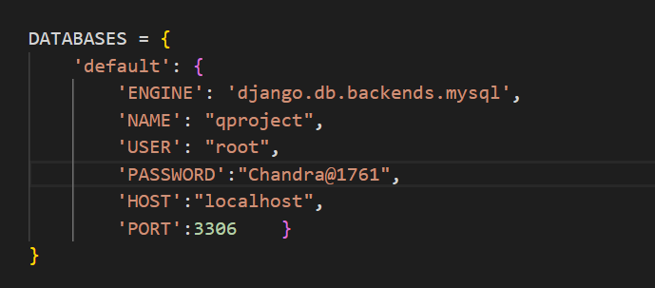

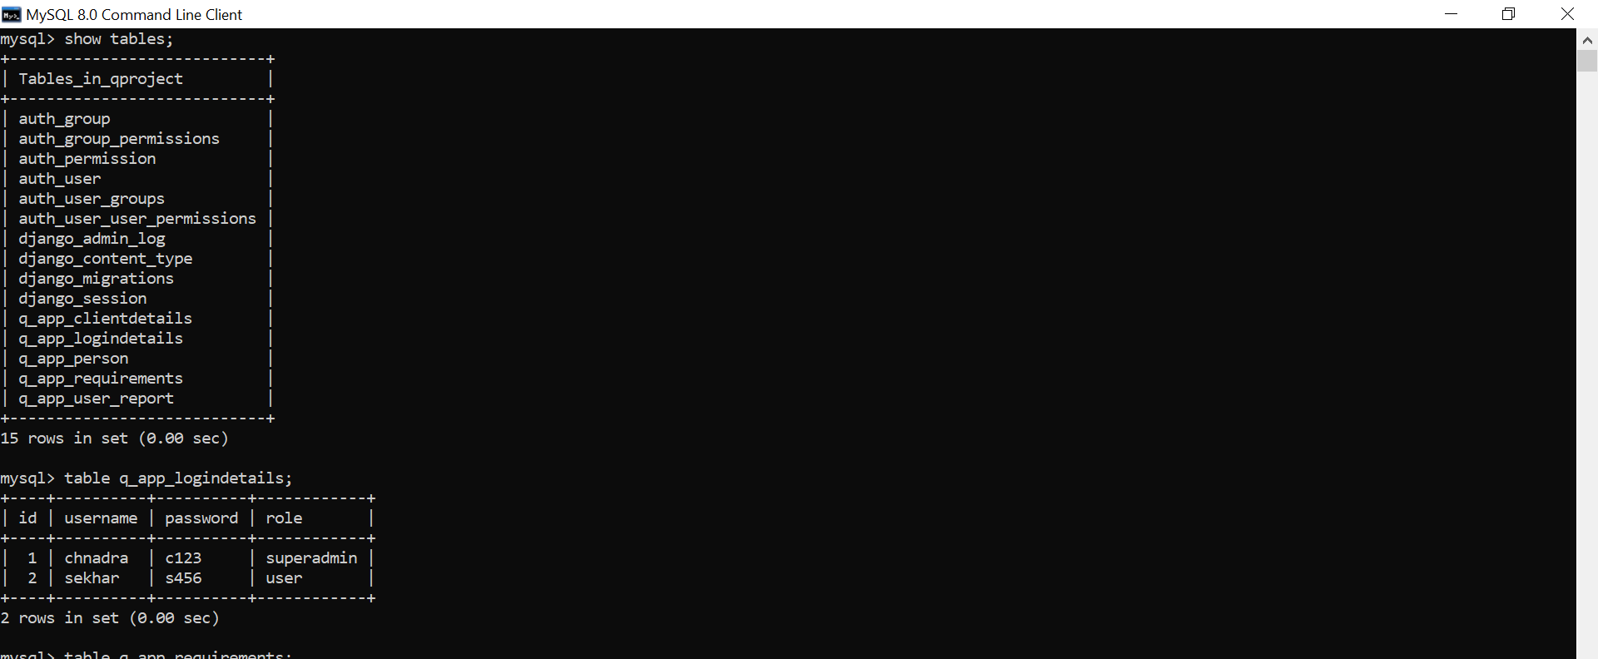

**Conclusion:**

The Login Page with client form, Task Requirement Form,Report form, client details, Task details is an essential for Client to manage their company revenue through publishing of an advertisement, depend upon number of views,clicks the total planned impressions, planned cpa,total planned cost will be genetrated. This documentation has provided an overview of the Super admin login page and the features available on the client details form and report form pages.

**THANK YOU**